Login2Xplore JsonPowerDB

1.JsonPowerDB and its features

JsonPowerDB is a high-performance, real-time database management system designed for modern applications. It focuses on providing speed, security, and flexibility.

Features of JsonPowerDB

1. **High Performance**: Optimized for fast processing and querying.

2. **Real-Time**: Allows immediate data management and updates.

3. **Ease of Use**: Simple setup with minimal configuration required.

4. **RESTful API**: Supports seamless integration with other applications.

5. **In-Memory Indexing**: Facilitates quick data access.

6. **Flexibility**: Accommodates multiple data types and structures.

7. **Scalability**: Efficiently handles increasing data volumes.

8. **Security**: Incorporates multi-layer security protocols.

2. JsonPowerDB use case and its benefits

JsonPowerDB Use Cases

1. **Web and Mobile Applications**: Ideal for applications requiring fast and real-time data handling.

2. **IoT Devices**: Suitable for managing and querying large volumes of data from connected devices.

3. **Analytics and Reporting**: Efficient for high-speed data analysis and generating reports.

4. **Document Storage**: Supports flexible document-oriented storage and retrieval.

### Benefits of JsonPowerDB

1. **Speed**: High performance ensures quick data processing.

2. **Scalability**: Can handle growing data volumes efficiently.

3. **Ease of Integration**: RESTful API facilitates easy integration with other systems.

4. **Flexibility**: Supports various data types and structures.

5. **Security**: Multi-layer security protects data integrity.

3. PUT Command - Creating (Inserting) RecordPage

The PUT command in JsonPowerDB is used to create or insert a new record into the database. Here’s how you can use it:

Syntax:

```plaintext

PUT /<DB-Name>/<Collection-Name>/{Primary Key}

Content-Type: application/json

{

"field1": "value1",

"field2": "value2",

...

}

```

### Example:

#### Request:

```http

PUT /exampleDB/employee/123

Content-Type: application/json

{

"name": "John Doe",

"age": 30,

"department": "Sales"

}

```

#### Response:

```json

{

"status": "success",

"message": "Record inserted successfully",

"data": {

"name": "John Doe",

"age": 30,

"department": "Sales"

}

}

```

### Steps:

1. **Specify the Database and Collection**: Use the format `/DB-Name/Collection-Name/{Primary Key}`.

2. **Define the Data**: Provide the data to be inserted in JSON format.

3. **Send the Request**: Make an HTTP PUT request with the data.

### Benefits:

- **Efficiency**: Quick insertion of records.

- **Flexibility**: Easily insert different data structures.

- **Real-Time**: Immediate reflection of inserted data.

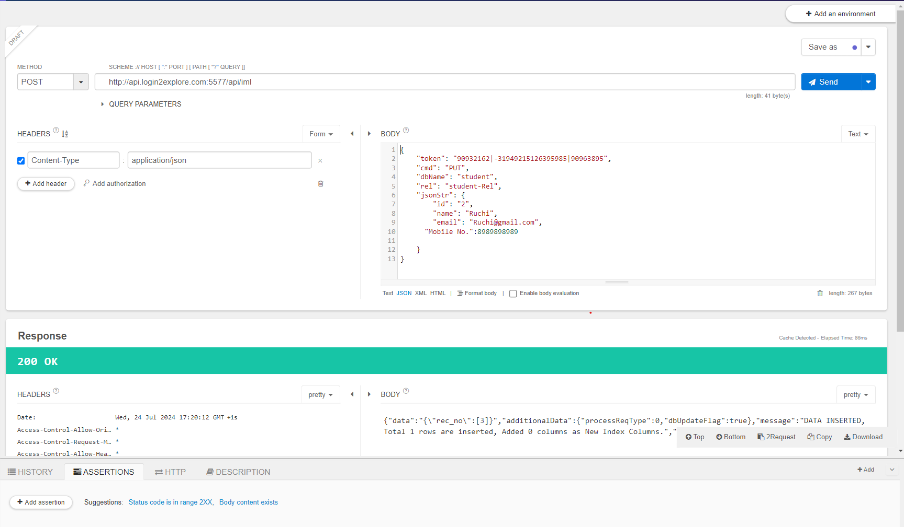

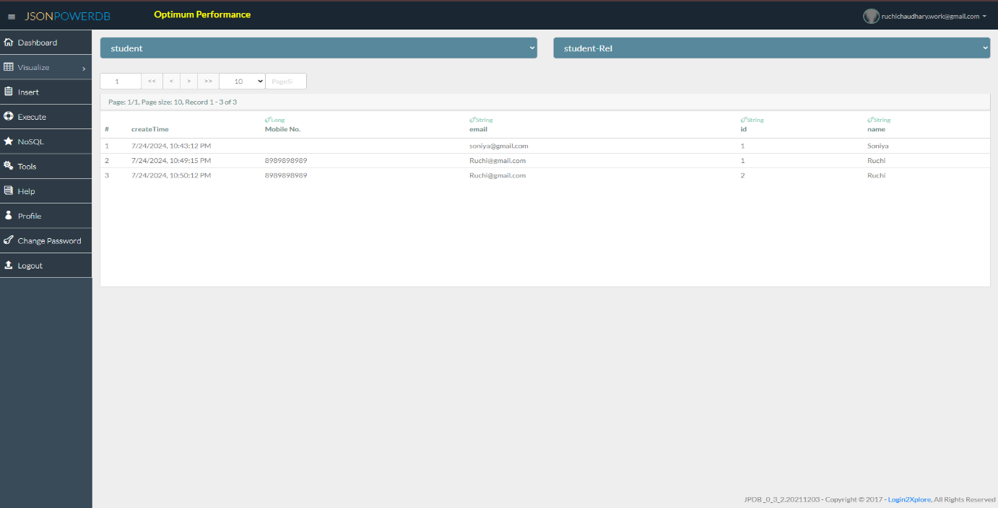

4.GET Command - Retrieving a Record in JsonPowerDB

The GET command in JsonPowerDB is used to retrieve a specific record from the database.

#### Syntax:

```plaintext

GET /<DB-Name>/<Collection-Name>/{Primary Key}

```

### Example:

#### Request:

```http

GET /exampleDB/employee/123

```

#### Response:

```json

{

"status": "success",

"data": {

"name": "John Doe",

"age": 30,

"department": "Sales"

}

}

```

### Steps:

1. **Specify the Database and Collection**: Use the format `/DB-Name/Collection-Name/{Primary Key}`.

2. **Send the Request**: Make an HTTP GET request.

3. **Receive the Response**: The response contains the requested record.

### Benefits:

- **Quick Access**: Fast retrieval of records.

- **Real-Time Data**: Immediate access to up-to-date information.

- **Simplicity**: Easy to use with minimal configuration.

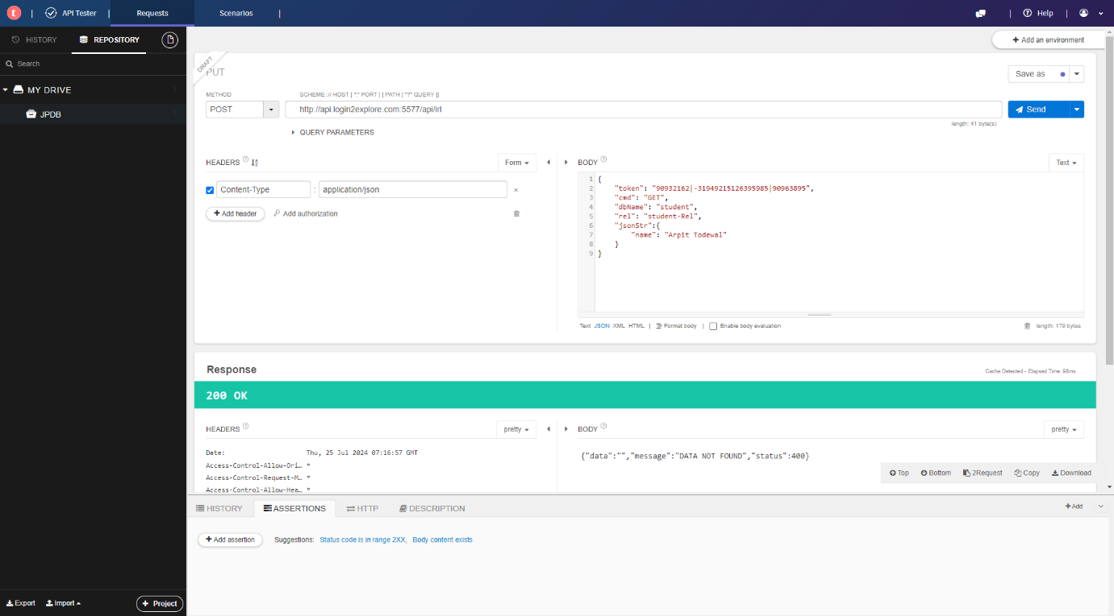

5.UPDATE Command - Updating a Record in JsonPowerDB

The UPDATE command in JsonPowerDB allows you to modify an existing record, requiring authentication via a token.

#### Syntax:

```plaintext

PUT /<DB-Name>/<Collection-Name>/{Primary Key}

x-access-token: <your-token>

Content-Type: application/json

{

"field1": "new_value1",

"field2": "new_value2",

...

}

```

### Example:

#### Request:

```http

PUT /exampleDB/employee/123

x-access-token: your-token

Content-Type: application/json

{

"age": 31,

"department": "Marketing"

}

```

#### Response:

```json

{

"status": "success",

"message": "Record updated successfully",

"data": {

"name": "John Doe",

"age": 31,

"department": "Marketing"

}

}

```

### Steps:

1. **Specify the Database and Collection**: Format as `/DB-Name/Collection-Name/{Primary Key}`.

2. **Include Token**: Add `x-access-token` header with your token.

3. **Define the Updated Data**: Provide the new data in JSON format.

4. **Send the Request**: Make an HTTP PUT request with the updated data and token.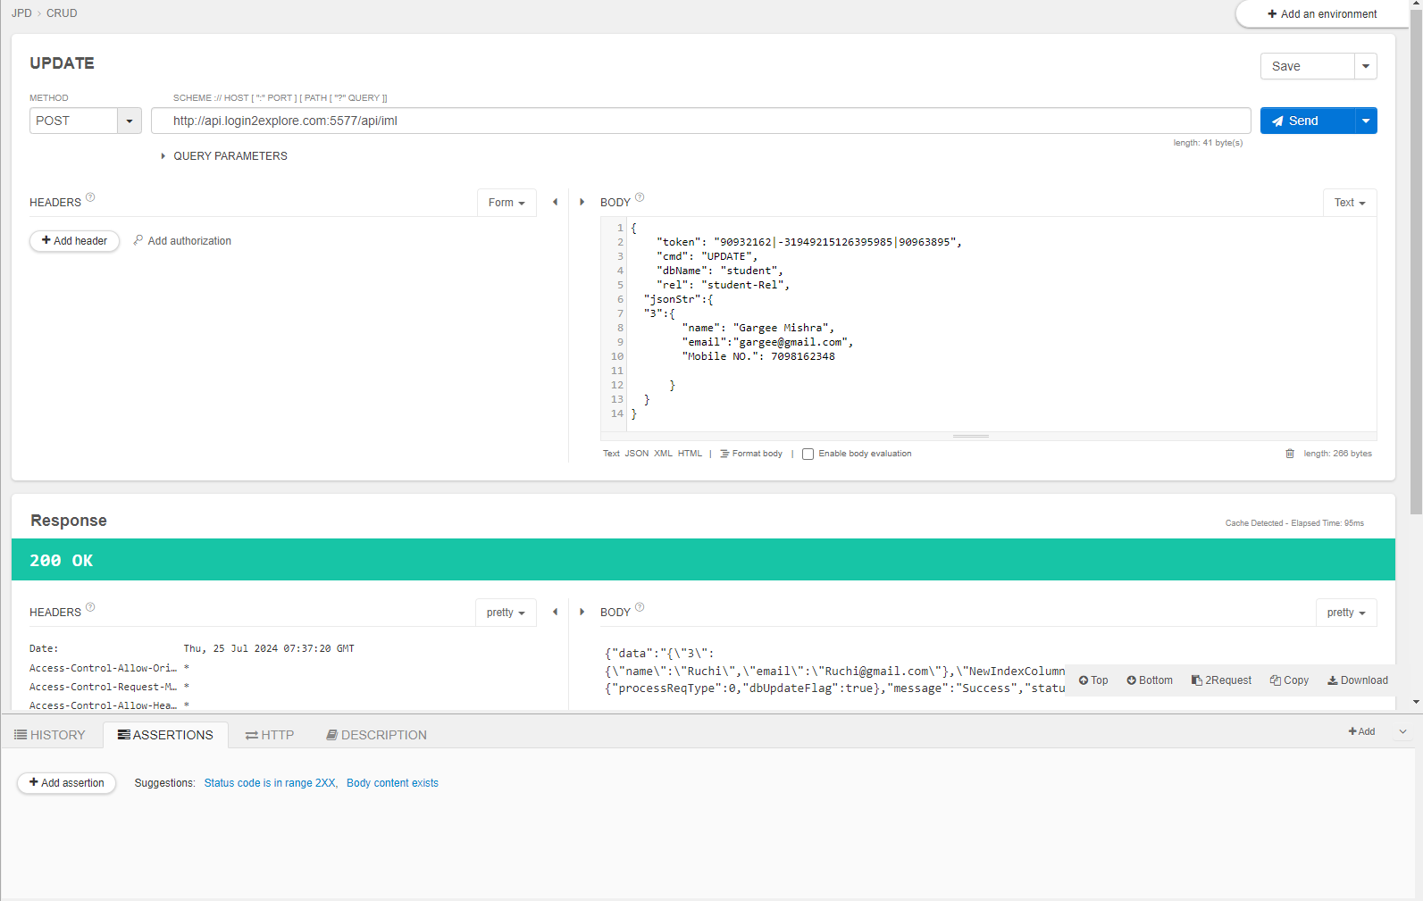

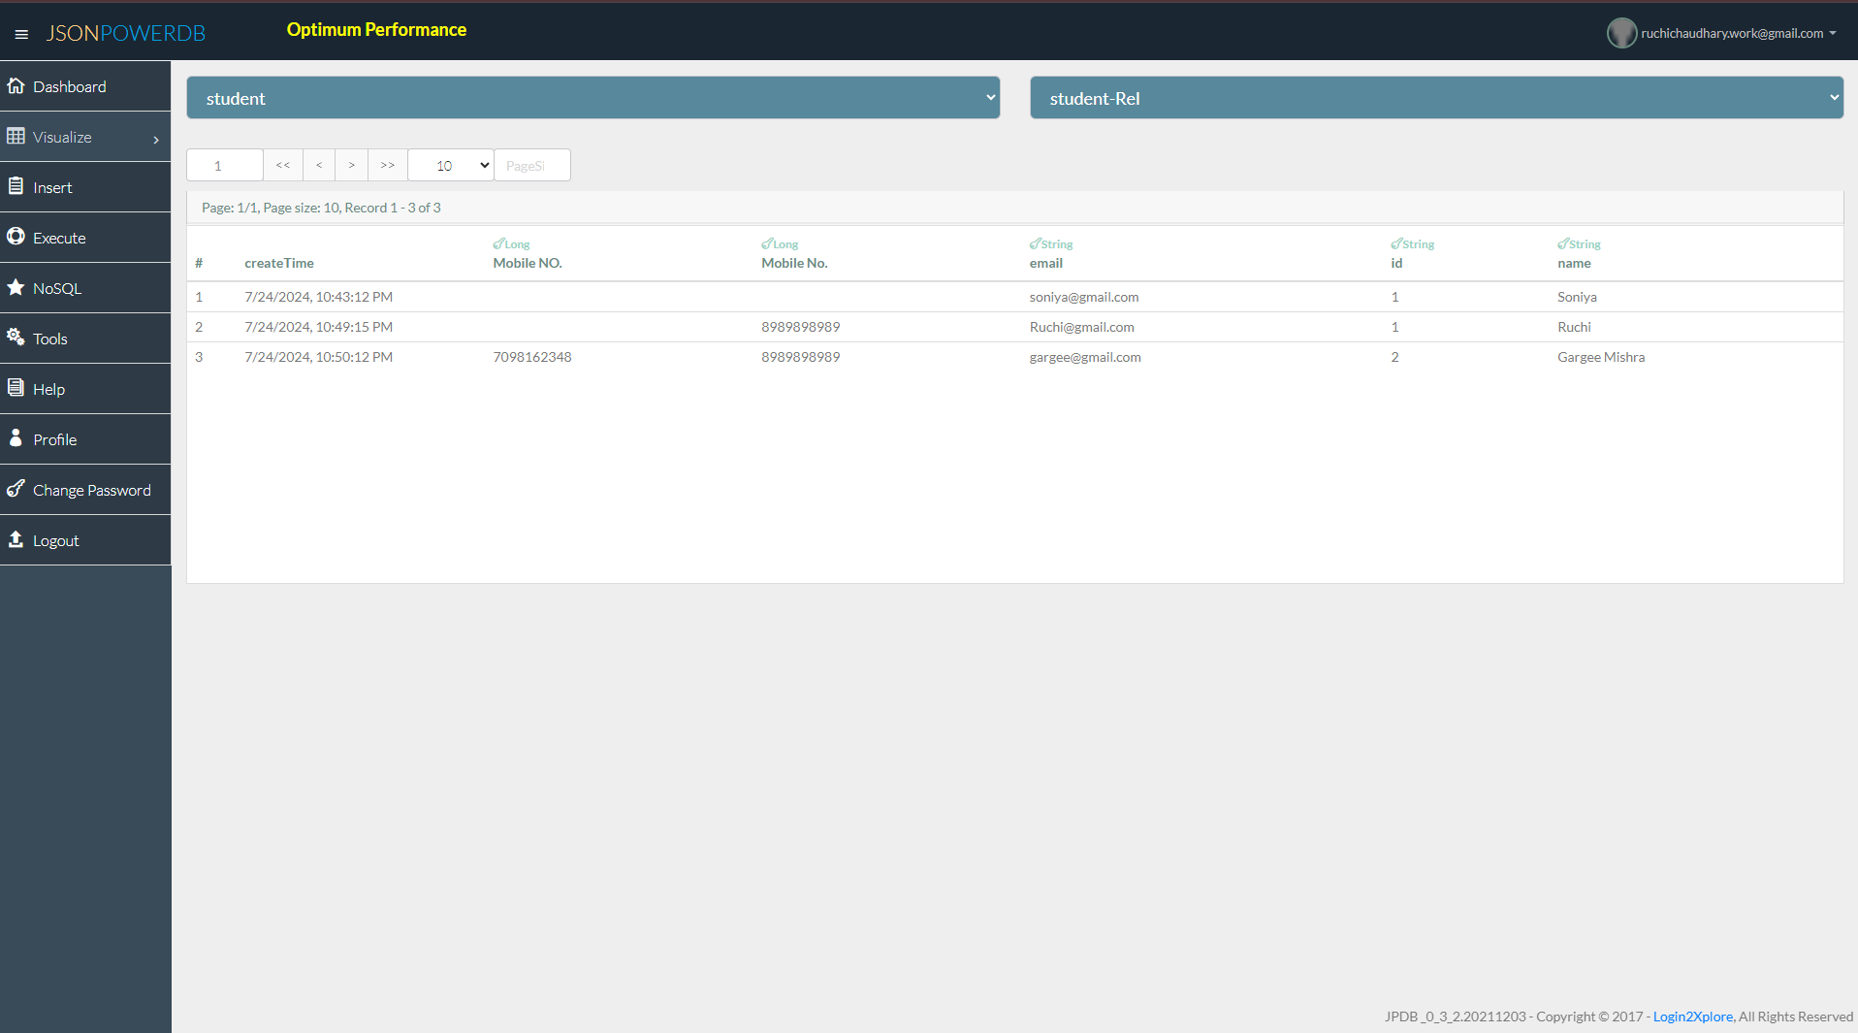

6. REMOVE Command - Removing a Record in JsonPowerDB

The REMOVE command in JsonPowerDB is used to delete a specific record from the database, and it requires an authentication token.

#### Syntax:

```plaintext

DELETE /<DB-Name>/<Collection-Name>/{Primary Key}

x-access-token: <your-token>

```

### Example:

#### Request:

```http

DELETE /exampleDB/employee/123

x-access-token: your-token

```

#### Response:

```json

{

"status": "success",

"message": "Record removed successfully"

}

```

### Steps:

1. **Specify the Database and Collection**: Use the format `/DB-Name/Collection-Name/{Primary Key}`.

2. **Include Token**: Add `x-access-token` header with your token.

3. **Send the Request**: Make an HTTP DELETE request with the token.

